**SOAP to SFTP Dynamic File Name**

Step 1: Utilize the same package of Exercise 1, but create a new Iflow say IF_SOAP_TO_SFTP_Dynamic_FileName_<CORPID> and Enter the Description as, “*Iflow for SOAP to SFTP with Dynamic File Naming*”

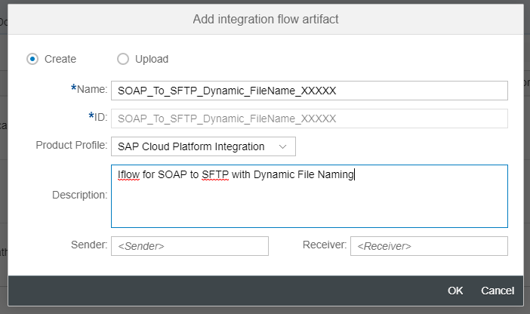

Step 2: Open the IFlow and Change the Sender Participant to “*SOAP_UI*” and Target Participant to “*SFTP_R*”

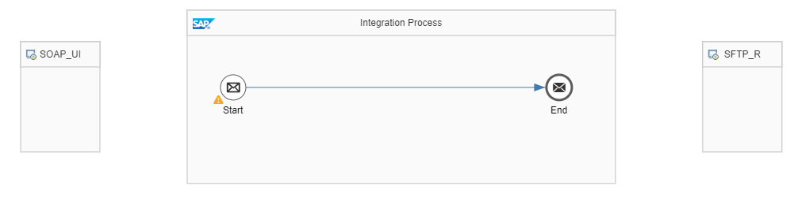

Step 3: Connect the Sender Participant “*SOAP_UI*” to Start and use the SOAP adapter with SOAP 1.1 as protocol. Configure the Connection Tab as per below. Don’t make changes to WS-Security or Conditions tab.

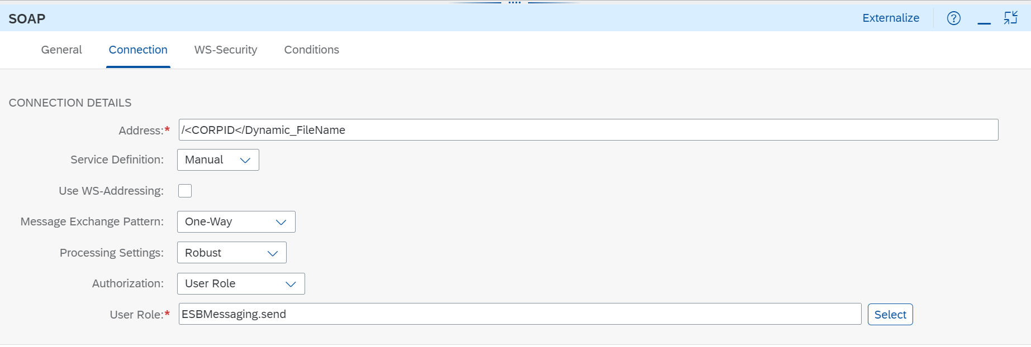

Note: SOAP Address can be anything, but for practice purpose use the naming convention. This will be the end point URL for the Interface to trigger.

Step 4: In the pallet, choose Transformation -----> Content Modifier and drop it in-between Start and End Message. Change the Name of Content Modifier to FileName

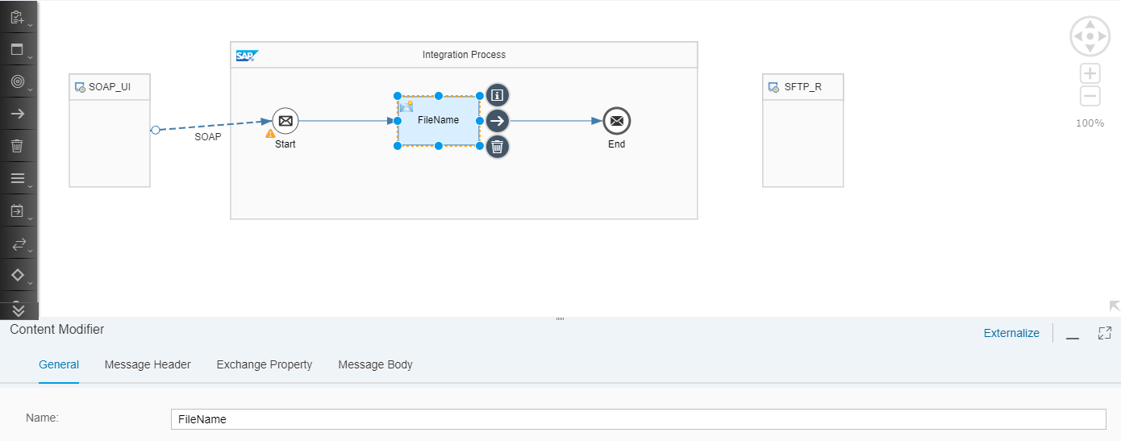

Step 5: Click on the Message Header Tab.

Add two line Items. One is for Name and one is for Empid.

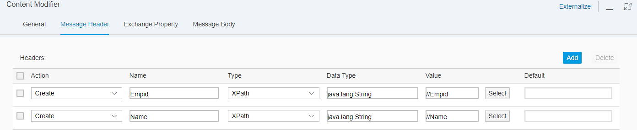

(*Explanation: Empid and Name will be taken from xpath of source*)

Step 6: Click on the Exchange Property Tab.

Enter the following Exchange Property.

Properties:

Action: ***Create***

Name: ***CamelFileName***

Type: ***Expression***

Value: ***${header.Empid}_${header.Name}.xml***

${header.Empid}_${header.Name}.xml

Step 7: Connect the End message and Target Participant “*SFTP_R*” and use SFTP connector.

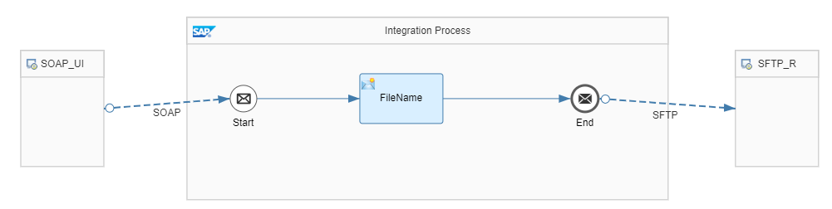

Step 8: In SFTP connector, Target Tab and enter the following details under Connection Parameters.

Address: 18.210.196.159

Credential Name: Autocloud_SFTP

Enter the following details in file access parameters. *${property.CamelFileName}*

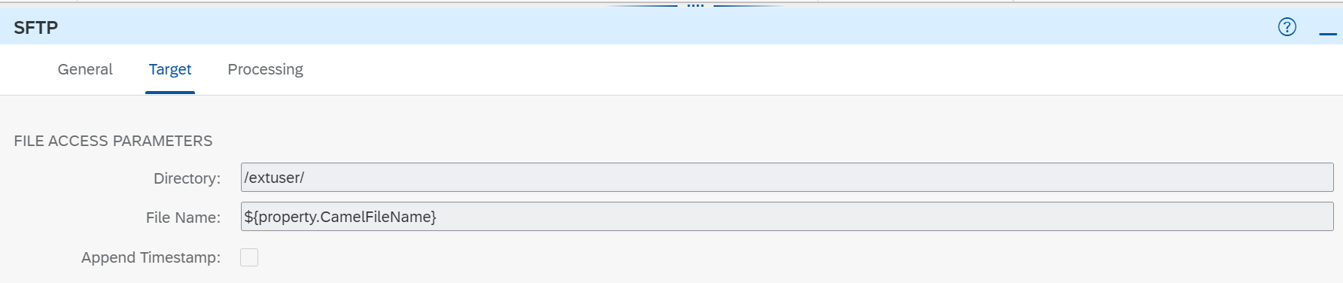

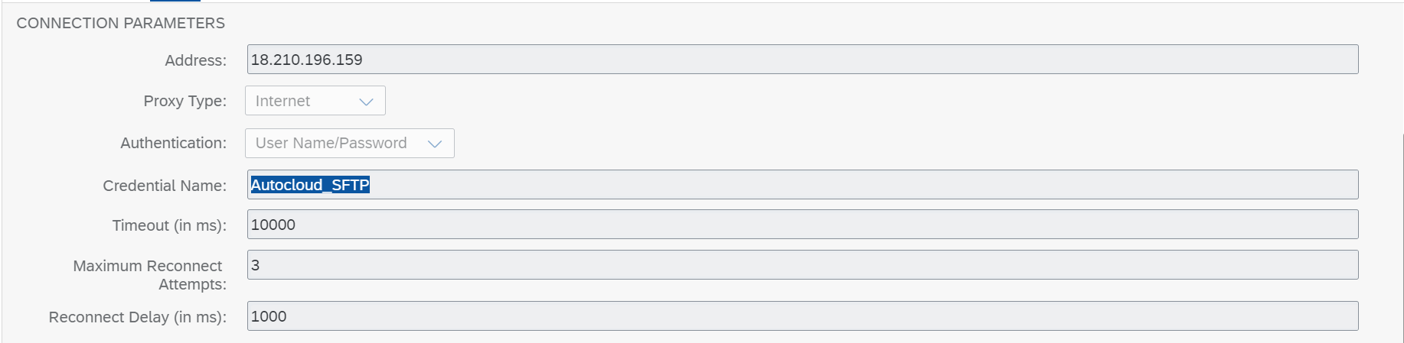

Maintain the Processing and Advanced Tabs as show in below screenshots

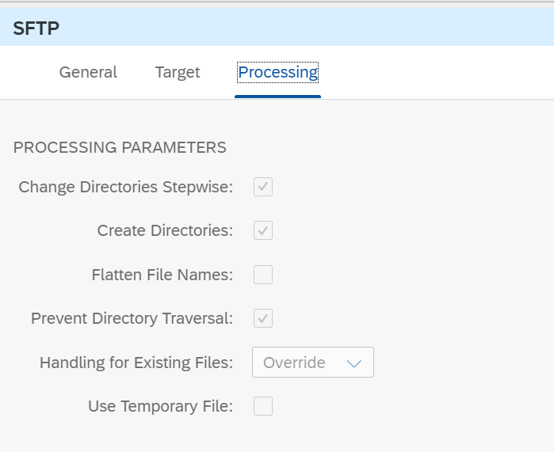

Step 9: Save the Integration Flow

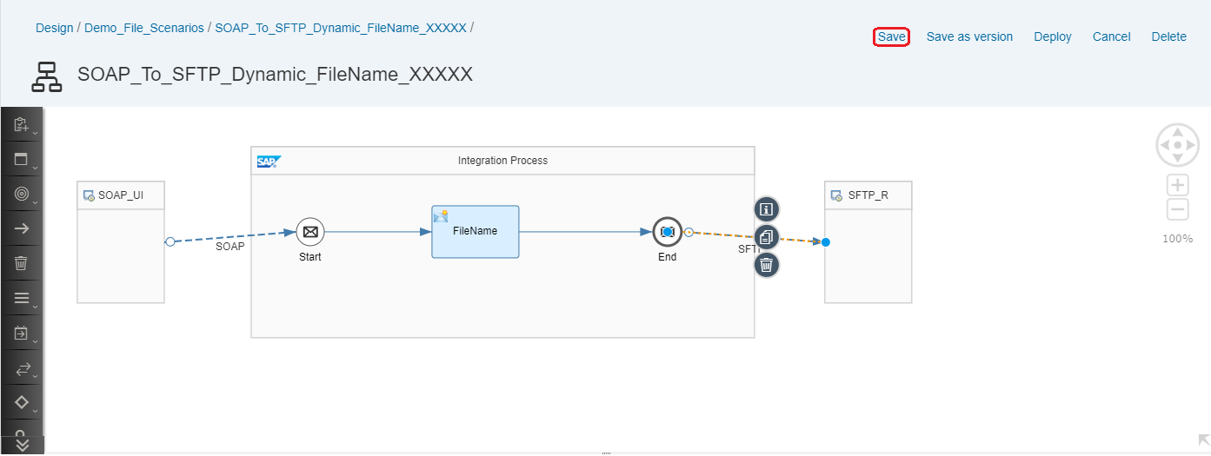

Step 10: Deploy the IFlow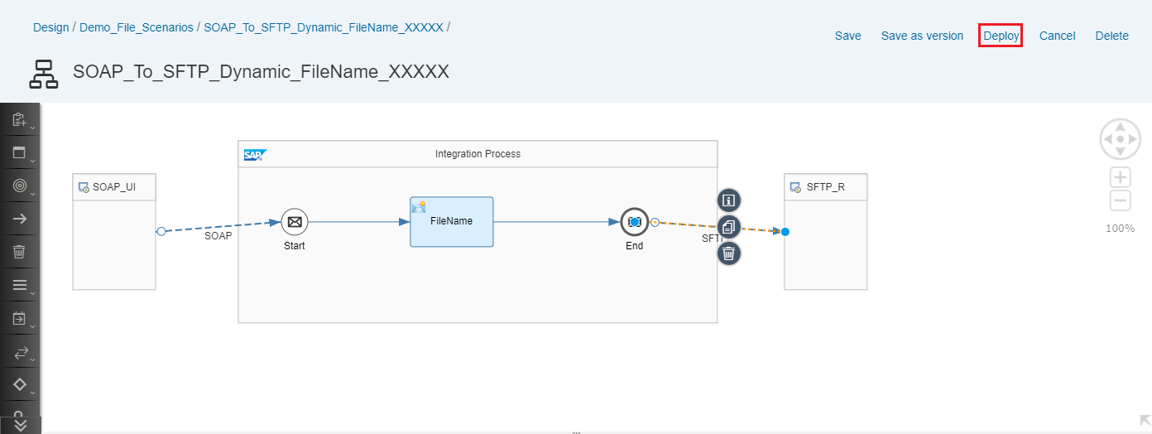

Step 11: Once Deployed, Goto Monitor

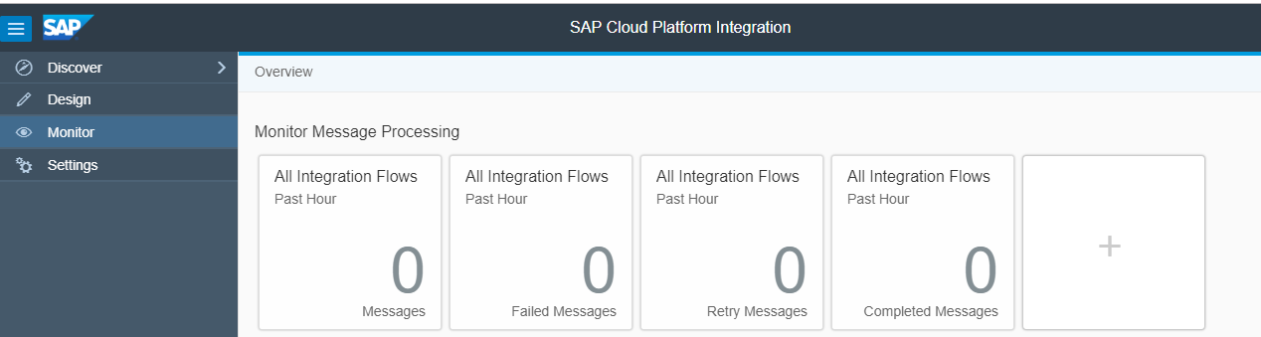

Click on “*All”* tile of Manage Integration Content

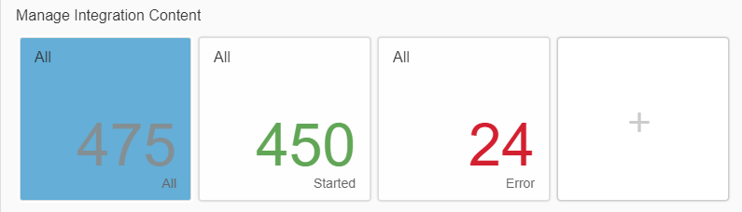

The status of the Integration Flow should be started

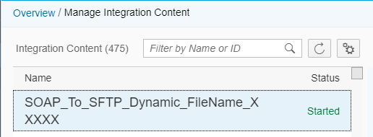

Step 12: Now we are good with the Integration flow. The next step is configure the end point in SOAP UI. Copy the end point from Monitor tab. Note. Copy the correct WSDL URL

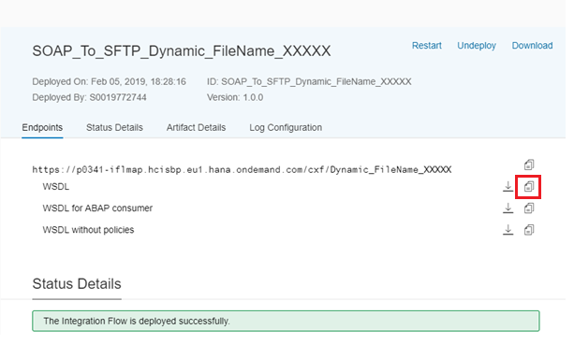

Step 13: Open SOAP UI and create new project and give a suitable name. In the Initial WSDL, paste the URL and click on OK. Once you login, it will ask for Basic Authentication, Enter the S-user ID and Password.

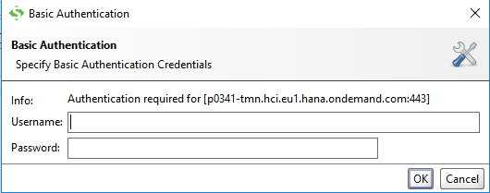

Step 14: The project is created. Now double click on Request 1.

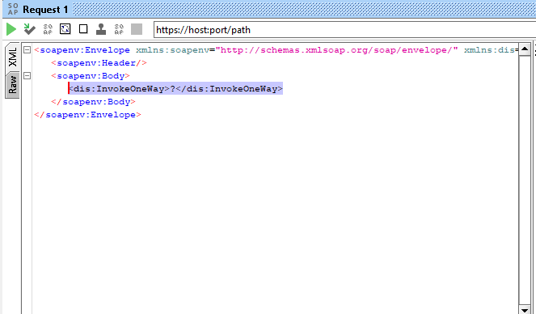

Step 15: Replace the highlighted text in above screenshot with the below payload.

<EmpDetails>

<Empid>1001</Empid>

<Name>John</Name>

<Phone>9856543210</Phone>

<Addr>Bangalore</Addr>

<State>KA</State>

<Client>CPI_CLIENT</Client>

<BU>NA</BU>

<EOM>No</EOM>

</EmpDetails>Step 16: Goto Manage Integartion Content and open your Iflow. Now copy the end point URL as shown in below screenshot.

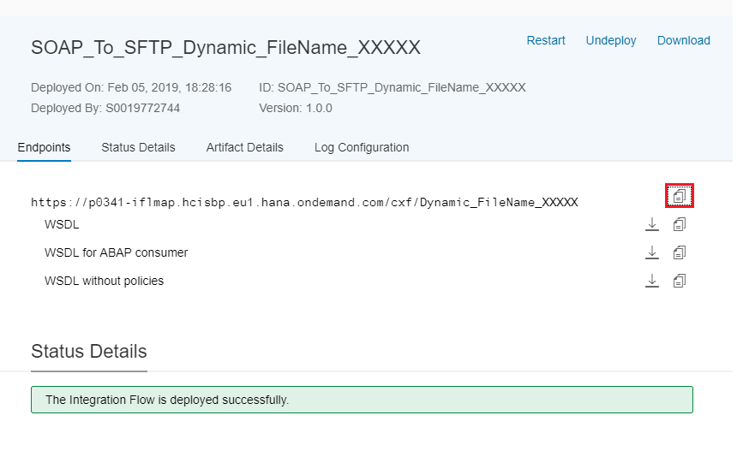

Step 17: Paste in the Address bar of SOAP UI

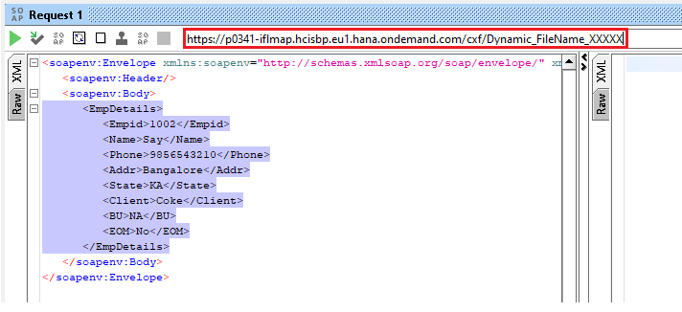

Step 18: Maintain the Access credentials in Properties tab of SOAP UI

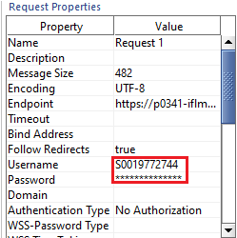

Step 19: Go To the Manage Integration Contents ---> <your iflow>-----> Log Configuration----> Log Level and Change it to Trace

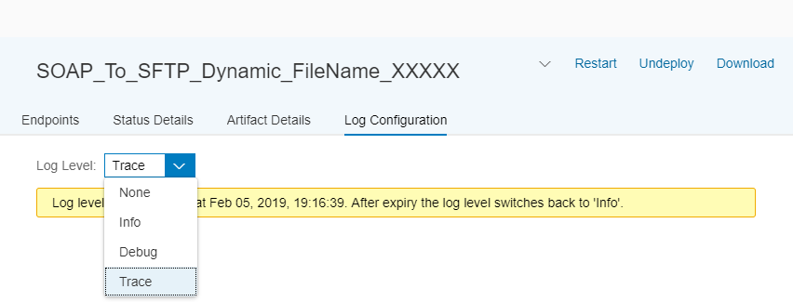

Note: This trace will be enabled only for 10 mins.

Step 20: Now goto SOAP UI and trigger the message

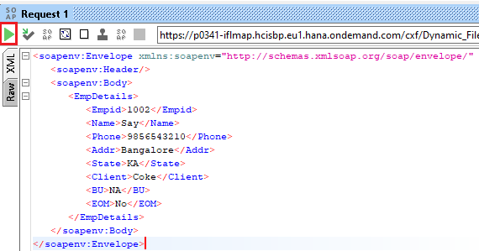

Step 21: Monitor Page and check for Monitor Message Processing

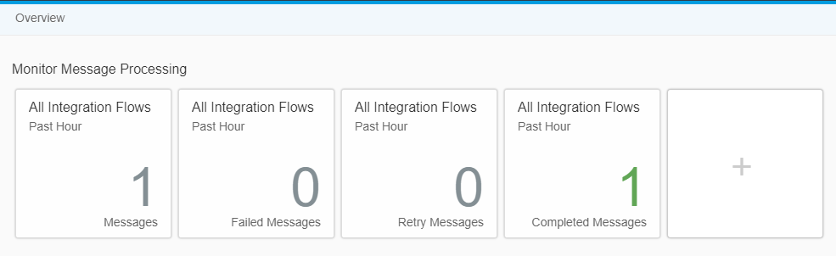

Step 22: Check for Message

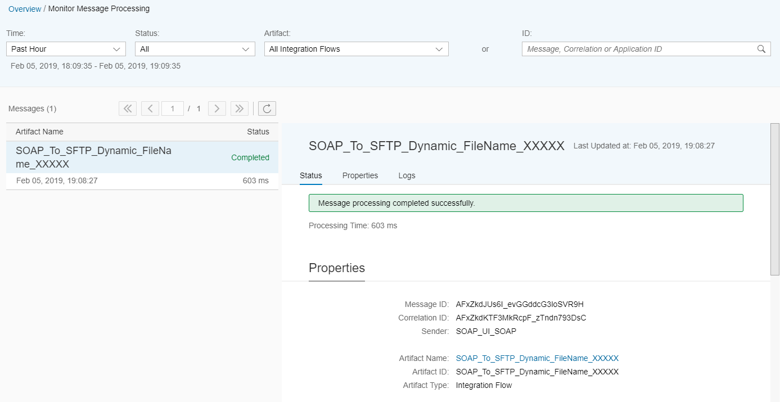

Step 23: Click on Log ---> Trace

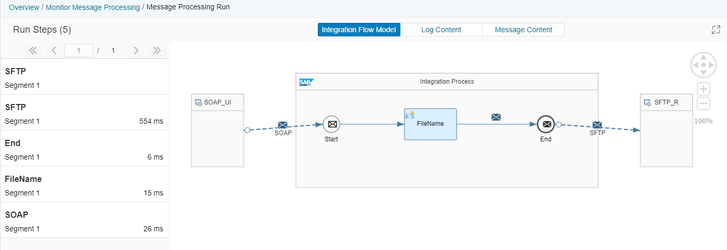

Integration Flow Model explains the flow of message from each block.

When you click on the SFTP block and look into Log Content Tab, you will find out the dynamically assigned Directory and file name against produced File.

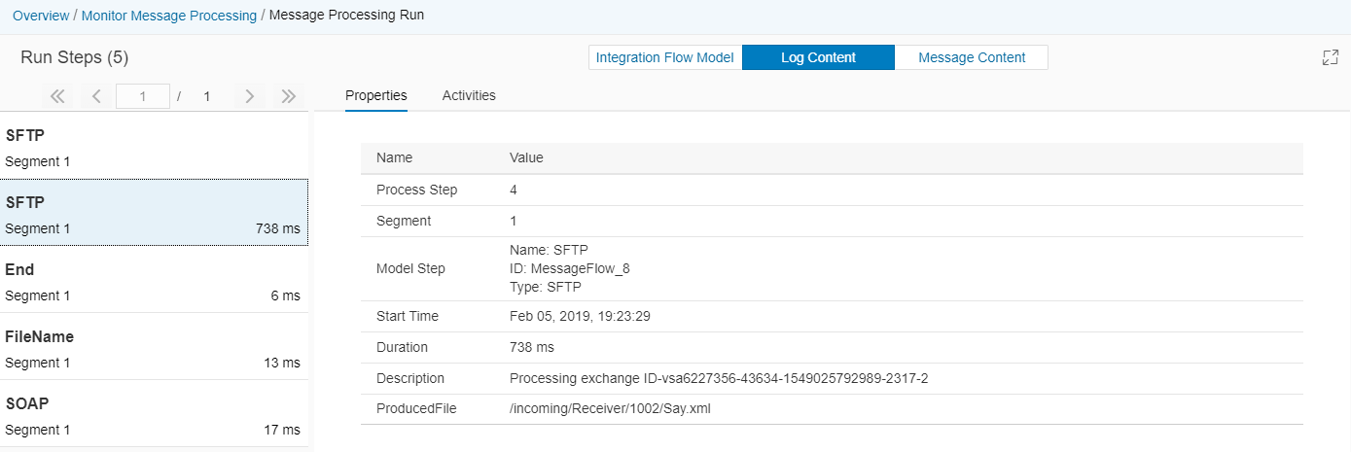

Login to any simulation tool for SFTP (say WINSCP) you can cross check the file

